Testing report from <https://data55.herokuapp.com/>

1.Students Registration;

Validation errors without entering the information into form

Auto pop up text; attempting to register your new account

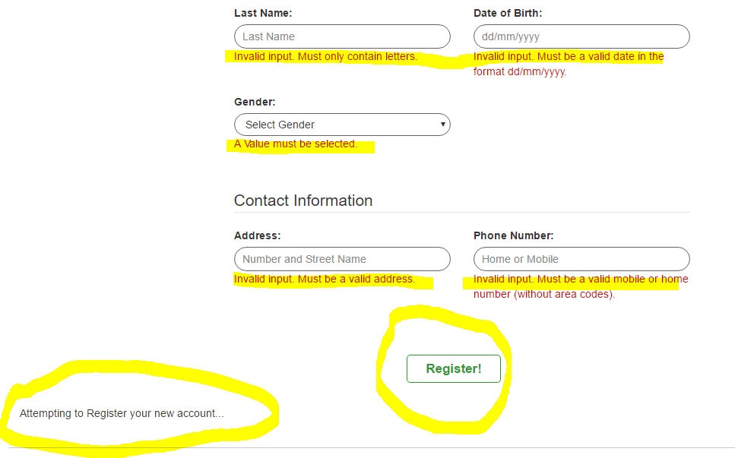

Rest of the pages and navigates smoothly and working fine so far.